Supplementary Material

Table S1 Primers used in this study.
Primers | Sequence (5’-3’)
inositol-synthetic pathway
TbIPS-F | GCGCGGCAGCCTCGAGATGCCGGCAGTGCGTACGAA
TbIPS-R | CCGAGCTCACCACTAGTTTAGCTGCCTACGCCACGC
EcIMP-F | GCGCGGCAGCCTCGAGATGCATCCGATGCTGAACATCGCC
EcIMP-R | CCGAGCTCACCACTAGTTTAACGCTTCAGAGCGTCGC
gene deletion
Δpgi-up-F | cattttcagccttggcacaa
Δpgi-up-R | GGCCTACATATCGACGATGATAGCAATACTCTTCTGATTT
Δpgi-down-F | aaatcagaagagtattgctatcatcgtcgatatgtaggcc
Δpgi-down-R | GGCAAAAATGCCATACAGAAC
ΔpfkA-up-F | TATATAGCGCGTTACGCATG
ΔpfkA-up-R | TCCGAAATCAGACTACCTCTGAACTTTGGAATGCAAAATG
ΔpfkA-down-F | AGAGGTAGTCTGATTTCGGAAAAAGGCAGATTCCTTTACC
ΔpfkA-down-R | GTGACTGACGAATCACCACG
ΔpykF-up-F | TCATGCCAACTATCAGCATA
ΔpykF-up-R | CACAAAAGCAATAGACAGTCTTAGTCTTTAAGTTGAGAAGGATGGGAG
ΔpykF-down-F | GACTAAGACTGTCTATTGCTTTTGTGAATTAATTTGTATATCGAAGCGCCCTG
ΔpykF-down-R | GAGCTGCGTCATCTTTAGCA
Δzwf-up-F | agaaacgattcaccgtcggt
Δzwf-up-R | ATAAAGGATAAGCGCAGATAGTCATTCTCCTTAAGTTAAC
Δzwf-down-F | gttaacttaaggagaatgactatctgcgcttatcctttat
Δzwf-down-R | CTGGATAGTGTTCATAAGGC
Δpgm-up-F | atccgacattttacggcgta
Δpgm-up-R | tacgcgtttttcagaacttccattgctttgtcctttgtct
Δpgm-down-F | agacaaaggacaaagcaatggaagttctgaaaaacgcgta
Δpgm-down-R | gttctttttcgttcccgcct
zwf regulation
zwf-RBSL1-up-F | GATGTAAAGAGACTCACGGGTAATG
zwf-RBSL1-up-R | GAGAAGCCTTTGGAACTTGGTACGACAAGTTAACTAACCCGGTAC
zwf-RBSL1-down-F | GTCGTACCAAGTTCCAAAGGCTTCTCATGGCGGTAACGCAAACAGC
zwf-RBSL1-down-R | TCCAGCATCGCGCCGAGACGGCTGAATG
zwf-RBSL2-up-F | GATGTAAAGAGACTCACGGGTAATG
zwf-RBSL2-up-R | GGTGCTGTAATAAAGGTGCTGGTGCAAGTTAACTAACCCGGTAC
zwf-RBSL2-down-F | GCACCAGCACCTTTATTACAGCACCATGGCGGTAACGCAAACAGC
zwf-RBSL2-down-R | TCCAGCATCGCGCCGAGACGGCTGAATG
zwf-RBSL3-up-F | GATGTAAAGAGACTCACGGGTAATG
zwf-RBSL3-up-R | AGGGTCGGCTTGCTTATTATACTCCGAAGTTAACTAACCCGGTAC
zwf-RBSL3-down-F | CGGAGTATAATAAGCAAGCCGACCCTATGGCGGTAACGCAAACAGC
zwf-RBSL3-down-R | TCCAGCATCGCGCCGAGACGGCTGAATG
zwf-RBSL4-up-F | GATGTAAAGAGACTCACGGGTAATG
zwf-RBSL4-up-R | TGGCTTATCCTAGATACGTGAGCGTAAGTTAACTAACCCGGTAC
zwf-RBSL4-down-F | ACGCTCACGTATCTAGGATAAGCCAATGGCGGTAACGCAAACAGC
zwf-RBSL4-down-R | TCCAGCATCGCGCCGAGACGGCTGAATG
zwf-RBSL5-up-F | GATGTAAAGAGACTCACGGGTAATG
zwf-RBSL5-up-R | GACTATTCCCCTGAAATGGTAAGAAAGTTAACTAACCCGGTAC
zwf-RBSL5-down-F | TCTTACCATTTCAGGGGAATAGTCATGGCGGTAACGCAAACAGC
zwf-RBSL5-down-R | TCCAGCATCGCGCCGAGACGGCTGAATG

Fig. S1 SDS-PAGE for expressions of IPS and IMP by optimizing plasmid expression systems.
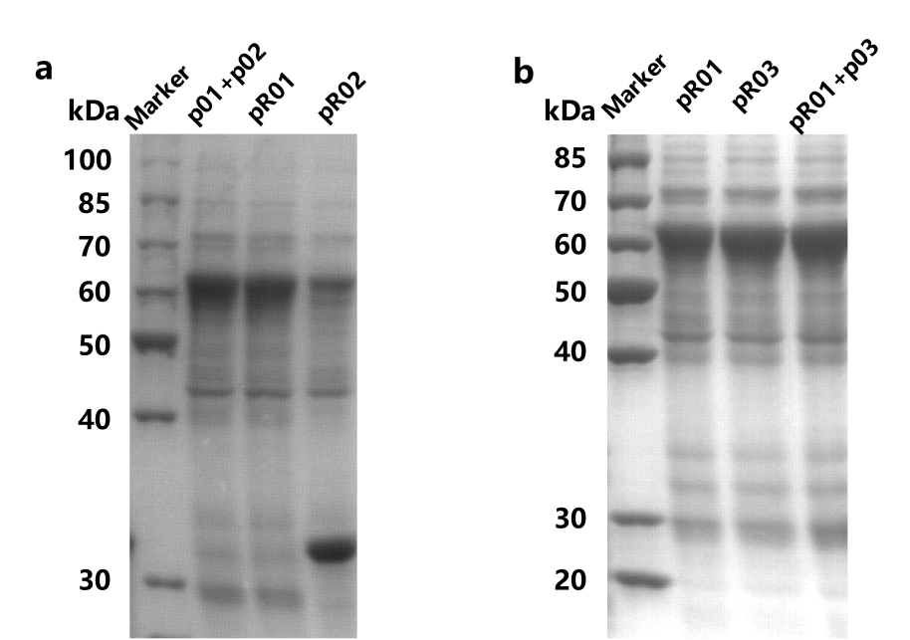

Fig. S2 Growth of engineered strain R04 in 1-L fermenter for high-density fermentation
